“Hi, my name is Rajballav Kumar. am from the 1st May batch, and this is my third assignment but my first thought note. Because I don’t know how to write a thought note, if any mistakes happen, please inform me at my [email-thegreatraj0810@gmail.com](mailto:email-thegreatraj0810@gmail.com) The email ID given by me earlier was hacked.

Create an HTML page that will fulfil the following requirements:

1. There should be 3 inputs, two will take the number, and the third with be dropped down for the operator.
2. There should be a submit button on click that calculates the answer.
3. On change of any input, the answer should be blank and need to click the button again.
4. The answer box should be read-only.
5. Should use bootstrap and JS for creating the following layout.
6. 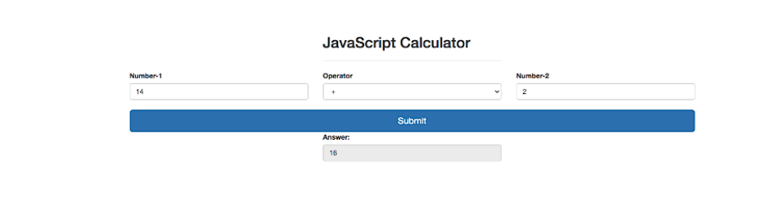You can change the text and background colour but don’t change the component placement.

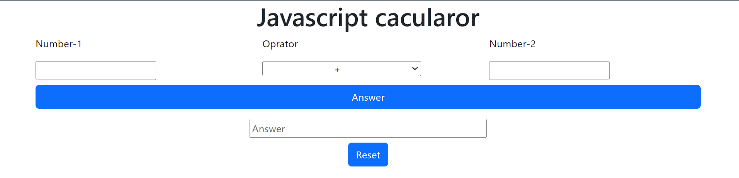>My output

In the given code, I first created a heading for the calculator using an h1 tag. Then I created the first row using Bootstrap to contain the input fields and operator. The operator has four options available: +, -, \*, and /. In the second row. I created a button called Answer which contains a JavaScript function to calculate the given input by the user. In the third row, I created an input field to contain the answer and gave it a property called ‘readonly’ so the user cannot input any data in the input field. In this row, there is another button called ‘reset’. When the user presses it, it will set the value of number 1,number 2 and answer box to null.

* In JavaScript, function1() is used to calculate the data given by the user.
* The reset function is used to empty the input field and the answer box.
* The remove function is used when the user makes any changes in number1 and number2 input fields; the answer box will be emptied automatically.
* Code for the given question

<!doctype *html*>

<html *lang*="en">

<head>

    <meta *charset*="utf-8">

    <meta *name*="viewport" *content*="width=device-width, initial-scale=1">

    <title>Javascript Assignment</title>

    <link *href*="https://cdn.jsdelivr.net/npm/bootstrap@5.3.1/dist/css/bootstrap.min.css" *rel*="stylesheet"

*integrity*="sha384-4bw+/aepP/YC94hEpVNVgiZdgIC5+VKNBQNGCHeKRQN+PtmoHDEXuppvnDJzQIu9" *crossorigin*="anonymous">

</head>

<body>

    <h1 *class*="text-center"> Javascript calculator </h1>

    <div *class*="row mx-5">

*<!-- for number-1 input -->*

        <div *class*="col-12 col-md-4  ">

            <p>Number-1 </p>

            <input *type*="number" *name*="num1" *id*="num1" *onkeyup*="*remove*()">

        </div>

*<!-- for oprator  -->*

        <div *class*="col-12 col-md-4">

            <p> Operator </p>

            <select *id*="operator" *class*="col-12 md-4 w-75 text-center">

                <option *value*="+">+</option>

                <option *value*="-">-</option>

                <option *value*="\*">\*</option>

                <option *value*="/">/</option>

            </select>

        </div>

*<!-- for number-2 input  -->*

        <div *class*="col-12 col-md-4">

            <p>Number-2 </p>

            <input *type*="number" *name*="num2" *id*="num2" *onkeyup*="*remove*()">

        </div>

    </div>

*<!-- for button answer  -->*

    <div *class*="row mx-5 mt-2">

        <div>

            <button *type*="button" *class*="btn btn-primary col-12 " *onclick*="*function1*()"> Answer

            </button>

        </div>

    </div>

    <div *class*="row mt-3 d-flex justify-content-center">

        <div *class*="col col-4 d-flex flex-column align-items-center">

*<!-- for showing the result -->*

            <input *type*="text" *name*="result" *id*="result" *class*="w-100" *readonly* *onclick*="*result*()">

*<!-- //for reset button -->*

            <button *type*="button" *id*="reset" *onclick*="*reset*()" *class*="btn btn-primary mt-2">Reset </button>

        </div>

    </div>

    <script>

*// this function will calculate the entered data*

*function* *function1*() {

*var* num1 = document.*getElementById*("num1").value;

*var* num2 = document.*getElementById*("num2").value;

*var* operator = document.*getElementById*("operator").value;

*var* result;

            if (operator *==* "+") {

                result = *Number*(num1) + *Number*(num2);

            } else if (operator *==* "-") {

                result = num1 - num2;

            } else if (operator *==* "\*") {

                result = num1 \* num2;

            } else if (operator *==* "/") {

                result = num1 / num2;

            }

            document.*getElementById*("result").value = result;

            console.*log*(result);

        }

*// using this function we can erase the inputs feileds*

*function* *reset*(){

            document.*getElementById*('num1').value=null;

            document.*getElementById*('num2').value=null;

            document.*getElementById*('result').value=null;

            document.*getElementById*('operator').value= "+";

        }

*// this function will erase result feiled when we try to change input data and make plus(+) default oprator*

*function* *remove*(){

            document.*getElementById*('result').value="";

        }

    </script>

    <script *src*="https://cdn.jsdelivr.net/npm/bootstrap@5.3.1/dist/js/bootstrap.bundle.min.js"

*integrity*="sha384-HwwvtgBNo3bZJJLYd8oVXjrBZt8cqVSpeBNS5n7C8IVInixGAoxmnlMuBnhbgrkm"

*crossorigin*="anonymous"></script>

</body>

</html>

